IEEE JOURNAL ON SELECTED AREAS IN COMMUNICATIONS, VOL. 22, NO. 9, NOVEMBER 2004

Performance Analysis of a Trafﬁc Engineering
Solution for Multilayer Networks
Based on the GMPLS Paradigm
Paola Iovanna, Member, IEEE, Marina Settembre, Member, IEEE, Roberto Sabella, Senior Member, IEEE,
Giulia Conte, and Lucia Valentini
1731

Abstract—This paper presents an integrated trafﬁc engineering
(TE) system for new generation multilayer networks based on
the generalized multiprotocol label switching (GMPLS) para-
digm, and reports the performance analysis of such a system.
The proposed TE system aims at dynamically reacting to trafﬁc
changes and, at the same time, fulﬁlling quality of service (QoS)
requirements for different classes of service. The proposed so-
lution consists of a hybrid routing approach and a bandwidth
management strategy. The former makes use of both off-line
and on-line methods to accommodate trafﬁc requests. The latter,
based on an “elastic” use of the bandwidth, allows the handling of
different priorities among data ﬂows, possible preemptions, and
rerouting. The proposed TE permits the accommodation of the
largest amount of trafﬁc, while guaranteeing good performance
to mission-critical services. The main building blocks and the
operations of the system are reported and the major advantages
are discussed. The performance of the proposed system are com-
pared with the ones relating to a reasonable alternative system
based on overprovisioning, to highlight its advantages of in terms
of trafﬁc volume that can be accommodated for a given network
infrastructure.
Index Terms—Generalized multiprotocol label switching
(GMPLS), multilayer networks, routing, trafﬁc engineering.

I. INTRODUCTION
I | T IS generally accepted that trafﬁc will be increasingly dom-  inated by Internet-based services, with respect to traditional

vice (QoS) for a subset of services that should be comparable to
that one provided by the telecom-based networks nowadays.
As a result, NGNs will have to be IP-centric, provide multi-
service capabilities, which means being able to support several
types of trafﬁc with different requirements in terms of QoS [2],
and be ﬂexible and dynamic enough to use at the best their re-
sources. Trafﬁc engineering (TE) plays a key role to cope with
these challenging requirements [3]. A promising solution to ac-
tualize TE in NGN is given by the generalized multiprotocol
label switching (GMPLS) paradigm [4]. GMPLS extends the
features of the well-known MPLS technique [5], [7] to both
packet and circuit switching network, providing a common set
of IP-based protocols to control heterogeneous network such as
ATM, SONET/SDH, and WDM [8], [9]. However, in practice,
the deﬁnition and analysis of a TE strategy exploiting the capa-
bilities of GMPLS is a very challenging task.
Many papers deal with speciﬁc TE functions such as routing,
wavelength assignment, and preemption algorithms [10]–[13]
in an optical layer, possibly overlaid to an electrical layer.
In those papers the two subproblems of 1) design of logical
topology of the optical network (i.e. the set of wavelength
paths) and 2) the routing of the data ﬂows at the IP/MPLS layer
onto the logical topology, are solved in a separate way (e.g., in
two different steps). Differently, a multilayer approach would
consist in simultaneously solving these two subproblems. A

voice trafﬁc, owing to the increased adoption of high-speed ac-
cess technology and the migration of more and more services
toward the Internet Protocol (IP). However, IP is a connection-
less, best-effort technology that was not designed for voice or
any other real-time service. Moreover, the peculiar character-
istics of Internet trafﬁc [1], such as its unpredictability and in-
stability, demand for new requirements for next-generation net-
works (NGNs): ﬂexibility and ability to promptly react to trafﬁc
changes. Overprovisioning, which is the common solution to
the problem of unpredictable bottlenecks in nowadays telecom
networks, it is not a cost-effective solution for new generation
networks. Moreover, the migration of all services over IP, in-
cluding the real-time ones, requires guaranteeing quality of ser-

Manuscript received May 27, 2003; revised March 3, 2004.
P. Iovanna, M. Settembre, and R. Sabella are with Ericsson Lab Italy, 00040
Rome, Italy (e-mail: paola.iovanna@ericsson.com).
G. Conte and L. Valentini are with CoRiTel-Research Consortium on
Telecommunications, 00040 Rome, Italy.
Digital Object Identiﬁer 10.1109/JSAC.2004.833839
TE strategy involving and combining speciﬁc TE functions in
a multilayer network has been reported in [14]. That paper also
presented the main building blocks and the mode of operations,
discussing the main characteristics of the system as a whole.
Key building blocks of that solution were reported in [15]–[17].
In particular, the routing problem has been approached in a
multilayer fashion, in the aforementioned sense. The present
paper reports for the ﬁrst time, to the best of our knowledge,
an integrated solution of TE in the technical details, the perfor-
mance analysis of this TE system as a whole, aiming at both
assessing its feasibility and evidencing its advantages with re-
spect to a relevant example among traditional overprovisioning
approaches.
This paper describes in Section II the reference network sce-
nario, and in Section III the realization of the network solution
previously reported in [14], addressing the above-mentioned is-
sues, by exploiting the GMPLS network model, in a multilayer
scenario. Section IV reports the results of the performance anal-
ysis accomplished by means of a simulation tool. Conclusions
and perspectives for future works are discussed in Section V.

0733-8716/04$20.00 © 2004 IEEE

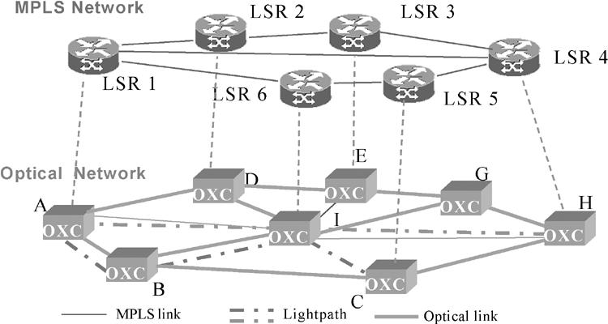
1732

Fig. 1. Multilayer reference network scenario.

II. REFERENCE NETWORK SCENARIO
IEEE JOURNAL ON SELECTED AREAS IN COMMUNICATIONS, VOL. 22, NO. 9, NOVEMBER 2004

actual link occupancy and the bandwidth requirement) by
means of an extended routing protocol (e.g., OSPF-TE). Hence,
CBR may ﬁnd longer but less-congested paths instead of
heavily loaded shortest paths, leading to a more uniform trafﬁc
distribution through the network and preventing congestions.
Multilayer routing allows leading to a more effective use of
network resources, considering the MPLS layer and the optical
layer jointly. That means that in a single routing instance an
LSP can be routed on a concatenation of optical paths.
Moreover, GMPLS can take advantage of suitable extension
of signaling protocol, (e.g., RSVP-TE), to allow the reserva-
tion of network resources, and of priority mechanisms to assign
resources to higher priority LSPs at expense of lower priority
LSPs, in order to efﬁciently handling QoS support.

It is widely recognized that MPLS technology, together with
proper constraint-based routing solutions, enables advanced TE
capabilities and support of QoS in an IP-based network [18]. In
fact, MPLS allows explicitly routing a trafﬁc request through the
network by forcing it on a speciﬁc path according to user and
network constraints and reserving the resources for that path.
Basically, MPLS re-proposes the concept of virtual connection,
previously introduced with ATM, but adopting IP-based sig-
naling and reservation protocols [19]–[21]. The virtual connec-
tion established by MPLS is called label switched path (LSP).
The MPLS routers achieving label switching are called label
switched routers (LSRs). An LSP can be set up, torn down,
rerouted if needed, and modiﬁed by means of the variation of
some of its attributes, including the bandwidth [21]. Further-
more, preemption mechanisms on LSPs can also be used in
order to favor higher priority data ﬂows at the expenses of lower
priority ones, to avoid congestion in the network [22]. Another
important feature of MPLS relates to the possibility of stacking
labels that provides the means of nesting an LSP into another
one of higher hierarchical level [5].
GMPLS extends the features of the MPLS technology [8],
[9], [23] In particular, it can manage heterogeneous network el-
ements, such as IP/MPLS routers, ATM switches, SDH/SONET
elements, or even optical elements, using a suitably extended
version of well-known IP protocol suite [24]. In fact, GMPLS
allows a single control plane to handle heterogeneous LSPs [25],
[26]. This means that a single instance of the control plane can
span multiple technologies, and an LSP of low order can be tun-
neled into an already existing LSP of higher order that acts as
a link. For sake of simplicity, but without losing generality, in
this paper a two-layer network is considered as reference sce-
nario. It consists of an IP/MPLS layer, whose network elements
are LSRs, and a WDM transport layer, whose nodes are optical
cross-connects (OXCs), as depicted in Fig. 1. Thus, just two
types of LSPs are considered: MPLS LSPs and optical LSPs,
which are usually called “lightpaths”; where a lightpath bun-
dles several MPLS LSPs.
From a routing perspective, GMPLS is adopted to provide
ﬂexibility and efﬁciency in the use of network resource. In fact,
GMPLS can exploit constraint-based routing (CBR) concept,
already developed in MPLS based networks, and multilayer
routing. CBR allows the calculation of the LSP routes taking
into account of network status and user constraints (e.g., the

III. TRAFFIC ENGINEERING SYSTEM FOR NEW GENERATION
MULTILAYER NETWORKS
The main goals of TE in new generation networks are the
optimization of the use of network resources, the actualization
of the “bandwidth-on-demand” concept, and the support of
different classes of service by guaranteeing the required QoS.
The proposed TE system aims at fulﬁlling those objectives,
by means of a hybrid routing approach, based on off-line and
on-line methods, and of a bandwidth engineering system that
adopts an “elastic” use of the bandwidth resource and priority
mechanisms.
The motivations for a hybrid routing originate from both
trafﬁc characteristics and practical implementation aspects
relating to routing. Trafﬁc entering a network can vary with
time, both in predictable and unpredictable ways. For instance,
legacy trafﬁc carrying traditional telephone services is easily
predictable, using well-known models, while Internet trafﬁc is
not. In general, the former type can be efﬁciently accommo-
dated through an off-line routing approach, which is adequate
for achieving a global optimization of route calculation based
on a foreseen trafﬁc matrix, particularly when a multilayer ap-
proach is adopted. Such an optimization of network resources
requires long computational time, which increases with the
network and trafﬁc size. On the other hand, Internet trafﬁc is
quite unpredictable and unstable. In this case, a pure off-line
approach can result unsatisfactory. In fact, the foreseen trafﬁc
matrix could strongly mismatch with the actual trafﬁc entering
the network. Overprovisioning, which is a common solution to
the problem of unpredicted bottlenecks, does not seem a viable
and cost-effective solution for the new generation IP networks,
since it could lead to book a huge amount of network resources.
Notwithstanding, a pure on-line routing approach, which con-
sists in evaluating the routes “on-demand,” is more adequate to
promptly react to trafﬁc changes, but it does not lead to the same
efﬁcient use of the network resources as in the case of off-line
approach, since it does not provide a global optimization.
As a result, the proposed hybrid routing solution combines
the off-line and the on-line methods to efﬁciently manage both
predictable and unpredictable components of trafﬁc.
In the presence of more than one class of service, the ﬂexi-
bility provided by the hybrid routing can be enhanced by means
of the module called bandwidth engineering (BE). The BE al-
lows better exploiting network resources by taking advantage

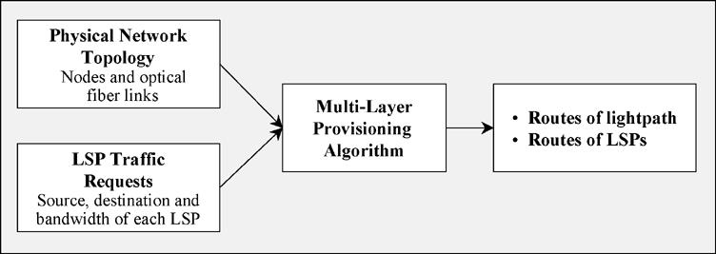
IOVANNA et al.: TRAFFIC ENGINEERING SOLUTION FOR MULTILAYER NETWORKS BASED ON THE GMPLS PARADIGM

of an “elastic” use of the bandwidth and suitable priority and
rerouting mechanisms, while at the same time fulﬁlling QoS
requirements. In practice, the BE functions operate so that the
temporarily unused reserved bandwidth of a higher priority LSP
can be released and put at disposal of lower priority requesting
LSPs, provided that the bandwidth is given back to higher pri-
ority LSP when needed. In other words, the bandwidth attribute
of any existing LSP can be varied on-demand according to spe-
ciﬁc trafﬁc requests, leading to an elastic bandwidth attribute. Fig. 2. Sketch of the provisioning module.
As soon as higher priority trafﬁc needs the released bandwidth, a
1733

procedure that handles preemption of lower priority LSPs is ac-
tivated. Moreover, the rerouting procedure can be used to move
lower priority trafﬁc on less-congested available routes, in order
to serve as much trafﬁc as possible. Essentially, the BE module
accomplishes its functionalities by means of bandwidth modify
mechanisms, preemption algorithms, and rerouting operations
according to a deﬁned priority policy.
For practical purposes, in the rest of the paper two main
groups of LSPs are identiﬁed. The LSPs belonging to the ﬁrst
group relate to the trafﬁc with very tight QoS requirements,
and they can be referred as higher priority (HP) LSPs. HP
LSPs are guaranteed at any time and in any trafﬁc conditions,
whatever is their bandwidth attribute, up to the maximum
value previously agreed by the SLA. The HP trafﬁc carries
presumably mission-critical services, such as voice and video
communications. The nature of this trafﬁc and the fact that it is
regulated by the SLA render it more easily predictable. Thus,
the network operator has to infer the trafﬁc matrix associated
to this trafﬁc taking care to dimension the connection requests
on their peaks resulting by the SLA. Then HP LSP routes are
calculated by means of the off-line procedure. On the other
hand, the LSPs belonging to the second group, relating to all
the other types of lower priority data ﬂows can be referred as
lower priority (LP) LSPs. The trafﬁc carried by LP LSPs can
be of various types of possible Internet services, with different
QoS requirements. That trafﬁc is much more unpredictable,
and can be estimated by means of statistical evaluations and
measurements. In addition, the LP LSPs are not guaranteed and
can be preempted if they are using the bandwidth required by
the HP trafﬁc. In this case, the network operator has to infer
the resulting portion of trafﬁc matrix according to its speciﬁc
policy. The issue stays in dimensioning each trafﬁc request on
a reasonable average estimation, without making an expensive
overprovisioning of the network resources. The way this is
done is above the scope of the present paper.
The considered TE solution employs the off-line procedure
to conﬁgure the optical and the MPLS connections, basing on
the trafﬁc matrix that represents the requested connections for
both HP and LP LSPs.
The TE system is designed to serve on-demand both HP and
LP trafﬁc, with a difference: HP trafﬁc routes, once calculated,
remain ﬁxed during their life unless another off-line procedure
is activated; while LP trafﬁc routes can be dynamically changed
from their originally assigned routes, according to the actual
network status. In order to efﬁciently use the bandwidth ca-
pacity, the TE strategy allows that HP trafﬁc consumes only
the amount of bandwidth that it really needs and for the time
it is necessary, and temporarily releases the unused bandwidth
to LP trafﬁc. Thus, bandwidth modify operations are dynami-
cally performed for HP trafﬁc, by means of the BE function that
preempts those LP-LSPs to make available the required band-
width for HP-LSP and tries to reroute the removed LP-LSPs
on less-congested routes. Bandwidth modify operations refer-
ring to a bandwidth decreasing request are achieved by known
modify MPLS mechanisms and the released bandwidth is put at
disposal for accommodating other requests.
The description of the integrated TE system is reported in the
following sections, where the hybrid routing solution and the
bandwidth-engineering module are reported.

A. Hybrid Routing Solution
1) Off-Line Routing: The Global Path Provisioning: The
off-line routing is actualized by the global path-PRovisioning
(PR) module, whose input and output are schematically
sketched in Fig. 2. Essentially, the PR module designs the op-
tical logical topology and calculates the LSP routes, according
to foreseen LSP trafﬁc requests and to the physical topology of
the network.
The foreseen trafﬁc requests represent an input data. It is as-
sumed that the network operators infer the trafﬁc requests for
both HP and LP LSPs through the knowledge of two types of
information: agreements stipulated with clients and estimations
made through statistical evaluations.
The physical topology of the optical network, assumed to be
set during the network planning phase, is composed of a set of
nodes connected by a set of links in a given mesh topology. Each
link bundles a set of ﬁbers between two adjacent nodes, and a
single ﬁber carries a certain number of wavelengths. Each node
can consist of either an LSR integrated with an OXC or a stand-
alone OXC. The OXCs are assumed to have full wavelength con-
version capability, without losing generality.
The output of the PR module consists of the set of lightpaths
(i.e., optical LSPs according to GMPLS LSP hierarchy) that rep-
resent the logical topology of the optical layer, and the routes for
all the LSPs groomed into the lightpaths of the logical topology.
Different objective functions can be deﬁned for the path-pro-
visioning problem according to the network operator policy. For
instance, the objective function could be the maximization of the
efﬁciency of network resources consumption (optical resources,
electrical resources or both), the minimization of the trafﬁc lost,
or the average packet hop distance [11], [12]. The speciﬁc ob-
jective function considered here is the minimization of the con-
gestion on the network resources. Formally, it is deﬁned as the
maximum ratio between used and available resources over all
the optical resources, that is, wavelengths on each optical link,
ports incoming to each LSR node, and ports outgoing from each
LSR node. The rationale is that minimizing congestion facili-
tates the dynamic routing operations; that is the accommodation

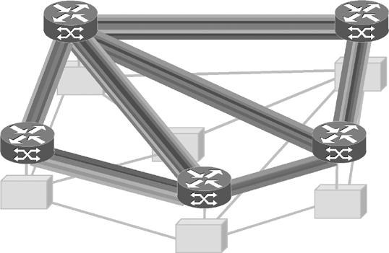

















1734

Fig. 3. Logical topology.
IEEE JOURNAL ON SELECTED AREAS IN COMMUNICATIONS, VOL. 22, NO. 9, NOVEMBER 2004

2) selecting the lightpath in the logic link, privileging the
choice of more ﬁlled wavelengths in order to facilitate the
accommodation of subsequent requests with more severe
bandwidth requirements.
The two criteria can be fulﬁlled by using a shortest path algo-
rithm with a weight function that takes into account of number
of hops between the source and destination nodes in the MPLS
layer, the capacity availability in logical links, and the capacity
availability on each lightpath in the logical link.
The weight function adopted in this paper has been derived by
extending the least resistance routing weight method [10] to our
GMPLS reference scenario, leading to the following formula:

of new connection requests or the handling of ﬂuctuations of the
trafﬁc demand.
The PR algorithm operates in a multilayer fashion. This
means that the selection of the lightpaths and the calculation

if

otherwise

(1)

of their routes on the physical topology are performed con-
currently with the calculation of the LSP routes on the logical
topology [15]. Obviously, solving the provisioning problem
with a multilayer approach increases the complexity of the
algorithm, but it leads to a more efﬁcient use of network
resources.
A heuristic procedure has been used to implement the al-
gorithm in the simulations. However, the “goodness” of the
adopted method (i.e., the estimation of the distance between
the obtained solution and the optimal one) has been tested by
means of a comparison with an algebraic algorithm, achieved
by solving the ILP formulation of the problem through the
optimization solver CPLEX under different conditions. The
results are reported in [15].
2) On-Line Routing: The Dynamic Path Selection: The DR
module evaluates “on-line” the route for the entering LP LSP
request, expressed in terms of source and destination nodes, and
bandwidth requirements, taking into account the updated link
state status of MPLS and WDM layers. In the proposed TE, it
is also used to reroute LSPs that have been preempted by the
bandwidth engineering operations.
For sake of simplicity, it has been assumed that the DR
module cannot set up new lightpaths, but it can only operate
on the logical topology derived during the off-line provisioning
phase. As a result, the establishment of one or more lightpaths
can only follow the decision of off-line providing a greater
logical capacity to the network (e.g., when a new Internet
Service Providers enters the network).
The logical topology provided by the PR module is enriched
with the information of bandwidth availability on each logical
link and on each lightpath constituting the logic link, learned
by a suitable extension of signaling protocol (e.g., OSPF-TE).
In fact, as shown in Fig. 3, each logic link between two LSRs
is constituted by a set of lightpaths connecting the two OXCs
integrated with those MPLS nodes.
The DR module aims at better utilizing network resources,
by using less-congested paths instead of shortest, but heavily
loaded paths. In order to accomplish this, the DR algorithm has
to concurrently satisfy two criteria:
1) ﬁnding the shortest route that minimizes congestion,
evenly distributing the trafﬁc at MPLS layer;
where is the available bandwidth in the MPLS link (as the
sum of individual spare capacities inside the wavelengths),
is the maximum link capacity in the MPLS network, is the
bandwidth required by the LSP, and is the available band-
width in the th wavelength of the th MPLS link. According
to the formula, the weight of a link increases as the available
aggregated capacity of that link decreases, while it is set to
when there is no wavelength, whose unused capacity is greater
than or equal to the required one. If it can be found a route with
a ﬁnite cost, the lightpath selection is performed by privileging
the choice of more ﬁlled wavelengths [16].
It is worth noting that the DR module can be regarded as
a CBR algorithm in which the constraint is the bandwidth re-
quirement associated to that request. Since the DR operates in a
multilayer scenario, it has to consider that bandwidth constraint
ranges in a continuous domain in the IP/MPLS layer, while the
resource at the optical layer range in a discrete domain (number
of wavelengths).
3) Hybrid Routing: It has to be highlighted that both the
above described on-line and off-line routing modules aim at im-
proving network performance (i.e., minimizing the utilization of
network resources and the blocking probability), but while the
former operates on the basis of a statistical estimation of trafﬁc
pattern, the latter operates on actual trafﬁc requests. Clearly, the
dynamic routing is able to handle the temporary congestion due
to the increment of actual trafﬁc volume and/or to the different
trafﬁc distribution among the nodes with respect to the estimated
trafﬁc considered in the provisioning phase.
To facilitate the integration of the PR and DR an opportune
ﬂexibility factor, , is introduced during the provisioning phase.
The basic idea is to suitably scale the physical topology during
the off-line procedure by reducing the bandwidth of each wave-
length, so that the PR module must select more lightpaths in
order to accommodate the same amount of foreseen trafﬁc. As
a result, the task of the DR module is facilitated since it oper-
ates on an enforced topology, at the expense of an increment
of physical network resources utilization. In other words, if the
factor is introduced and if the wavelength capacity is
, the wavelength bandwidth used during the PR procedure, is
limited to , while during the DR operation those lightpaths,
constituting the logical topology, are considered with their ac-
tual bandwidth, i.e., .






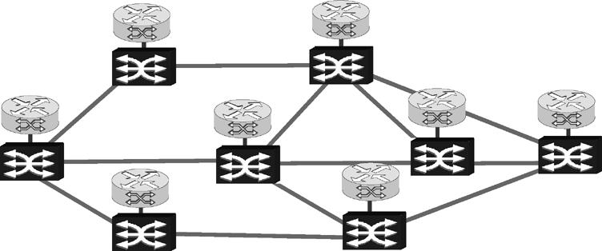











IOVANNA et al.: TRAFFIC ENGINEERING SOLUTION FOR MULTILAYER NETWORKS BASED ON THE GMPLS PARADIGM

The value of the factor , which leads to an improvement
of the dynamic network performance with a minimum number
of network resources, depends both on the network load and
on the relationship between the expected and the actual trafﬁc
[27]. The impact of the factor will be discussed in Section IV,
where the performance of TE are reported in different condi-
tions, to test the robustness of the solution itself to promptly
react to trafﬁc ﬂuctuations and unpredictability.

B. Bandwidth Engineering Fig. 4. Network topology.

The TE system is based on an elastic use of the bandwidth.
1735

This means that bandwidth assigned to higher priority LSPs
during the provisioning phase can be temporarily released for
the amount of time in which it is not needed and put at disposal
of all the other lower priority LSPs. This means that as soon as
the HP LSPs require back their bandwidth, the TE system im-
mediately has to satisfy that need in some way. In order to do
that, a function that handles preemption of lower priority LSPs
or, even better, that can move lower priority trafﬁc on less-con-
gested routes is needed. In [17] it was proposed a BE system for
that scope, that in this paper has been integrated as a module in-
voked in the integrated TE system. Speciﬁcally, BE makes use
of two key elements: 1) a bandwidth handling algorithm (BHA),
which selects those LP LSPs that need to be moved to make
available the bandwidth required by the HP LSPs and 2) the pre-
viously mentioned DR algorithm, which aims at rerouting those
selected LP LSPs on alternatives paths. In this way, BE allows
bandwidth resource to be managed in an effective way, with the
aim of both accommodating more trafﬁc with respect to classic
(non-TE) networks, and guaranteeing the required QoS for dif-
ferent CoS.
In particular, the BHA is invoked when an HP LSP requires
more bandwidth on its route and at least one link on that route
is congested because of the presence of other LP LSPs. Its op-
eration consists in selecting the LP LSPs that have to be moved
and rerouted by means of the DR. It is applied on all the con-
gested links of the HP path requiring more bandwidth. On each
congested link, it works iteratively until there is enough free
bandwidth to let the HP trafﬁc pass. Parameters used to calcu-
late weights are recalculated in each step of the iteration. Sev-
eral solutions have been investigated in [17]. The simplest one,
herein considered, is an implementation of the MinConn algo-
rithm reported in [22] for an IP/MPLS network. The BHA works
as follows.
1) Search for congested links: It proceeds sequentially along
the HP LSP, starting from the ﬁrst link of the HP LSP path.
2) Weight calculation of LP LSP, , related to the th LP
LSP on the th congested link:

(2)

where is the bandwidth to be released on the th link to
accommodate HP LSP request, is the band-
width used by the th LP LSP, crossing the link th.
3) Weight sorting, by increasing order (taking into account
the weight sign).
4) Selection of LP LSP: If there exists at least one positive
weight, the LP LSP with the lowest positive weight is se-
lected to be torn down from the link under evaluation and
the correspondent bandwidth is released on all the links
crossed by that LP LSP. The selected LP LSP is submitted
to a DR procedure so as trying to reroute it. If rerouting
fails, the LP LSP is torn down from the network by the BE
control. If there are only negative weights (when LP LSPs
bandwidths are singularly smaller than the bandwidth to
be free), iteratively, the algorithm selects more LP LSPs
until the constraint of the bandwidth to be free is satisﬁed.
Again, each selected LP LSP is passed to a DR procedure,
which reroutes it. If rerouting fails, that LP LSP is torn
down by the BE control.

IV. PERFORMANCE ANALYSIS
The objective of the performance analysis is to assess the fea-
sibility of the proposed integrated TE system. In particular, it is
interesting to evaluate:
1) the robustness of the solution with respect to different rel-
evant situations of trafﬁc demand;
2) the gain of adopting such a TE approach with respect
to the case in which an over-provisioning approach is
assumed;
3) the price to be paid, in terms of complexity, which can be
measured in terms of number of operations (preemptions).
Section IV-A reports the details of the analysis environment.
In particular, the network topology and the simulated trafﬁc be-
havior for both HP and LP classes are presented. Section IV-B
shows the achieved results for the multiservice network sce-
nario, in which the proposed TE solution is applied.

A. Analysis Environment
The physical network topology is depicted in Fig. 4. It is com-
posed by nodes and bidirectional optical links.
Each optical link supports 16 wavelengths, with a wavelength
capacity equal to Gb/s.
Both for HP and LP trafﬁc, the offered trafﬁc can be described
by a trafﬁc matrix, whose generic element is the aggregated
bandwidth considering the set of LSP requests between node
and node

HP LP (3)






















1736
IEEE JOURNAL ON SELECTED AREAS IN COMMUNICATIONS, VOL. 22, NO. 9, NOVEMBER 2004

The sum of the bandwidth requested by all the LSPs for each
pair of nodes is the trafﬁc volume (TV)
TV TV TV (4)

As far as HP trafﬁc is concerned, bandwidth modify events
are generated for each HP LSP. The arrival time of bandwidth
modify event is assumed to be uniformly distributed between
and , with mean . The amount
of bandwidth modify is uniformly distributed between and

In order to characterize the trafﬁc entering the network, a net-
, with mean
, where
is speciﬁed in

work load parameter , deﬁned as the ratio between the total of-
fered bandwidth and the network available bandwidth, has been
introduced:
TV
(5)

where is the average minimum distance between each pair of
source-destination nodes, and is the total available band-
width on the physical optical network.
In the simulations, the aggregated bandwidths are chosen ran-
domly. In particular, for each pair of nodes, and , a random
number uniformly distributed between 0 and 1, , is
picked so that the aggregated bandwidth of all the LSPs from
the HP trafﬁc matrix, and represents the SLA for each LSP.
Essentially, the trafﬁc generation is based on the assump-
tion that a trafﬁc matrix, derived by SLAs, is at disposal of the
provider for the HP trafﬁc; hence, the maximum actual trafﬁc is
assumed consistent with the estimated trafﬁc used in the provi-
sioning phase. In the case of LP trafﬁc, instead, the actual trafﬁc
can exceed and/or mismatch in spatial distribution the estimated
one. Thus, in order to test the robustness of the proposed TE so-
lution, three relevant case studies have been considered, which
correspond to different relationships between estimated and ac-
tual trafﬁc. In practice, the three cases differ from the level of
accuracy of information available on both the trafﬁc volume and
the aggregated bandwidths.

node to node , , is
, where is a scaling param-
Case 1: It corresponds to have an accurate a priori knowl-

eter. The scaling parameter is chosen so that
edge of the trafﬁc behavior. That means that the informa-
tion on both the trafﬁc volume and the aggregated band-

TV
HP LP
(6)
widths between each pair of source-destination nodes are
correct and, hence, that ,

According to the proposed TE strategy, the off-line procedure
operates using as input the estimated trafﬁc matrix, while the
on-line procedures (LP setup and HP bandwidth modify) op-
erate using as input the actual trafﬁc matrix.
In case of estimated trafﬁc, represents the average ex-
pected aggregated bandwidth from node to node . It is deter-
mined by statistical evaluations, when relates to LP trafﬁc. Dif-
ferently, it represents the maximum allowed amount of trafﬁc
from node to node , agreed by SLAs, when relates to HP
trafﬁc. In the simulations, the estimated trafﬁc matrix has been
derived by generating a set of LSP requests with , rep-
resenting the bandwidth associated to each LSP from node to
node , so that

(7)
where the subscripts and refer to actual and estimated
trafﬁc and the relation on the aggregated bandwidths is
valid for each .
Case 2: It corresponds to a case in which the information
on the total trafﬁc volume entering the network is correct,
but it is not known how the trafﬁc is distributed among the
source-destination network nodes. That means that only
parameter is equal for the actual and estimated trafﬁc:
.
Case 3: It corresponds to the worst case where the estima-
tion of trafﬁc volume and of the trafﬁc distribution among
network nodes is incorrect. Speciﬁcally, it has been as-
sumed that the estimated is 25% less than actual .
In all the simulations the value of the holding time
is assumed constant for all the LP LSP connections and it is
200 s. The LP LSP bandwidths are assumed to be uniformly
distributed from 1 to 500 Mb/s. For the HP trafﬁc, the average

where
and
represent the minimum and the maximum
modify holding time for each LSP is 2% of the simulation dura-

estimated bandwidth requested by an LSP in case of LP trafﬁc,
while they represent the range values deﬁned for the SLAs, for
HP trafﬁc.
In case of actual trafﬁc matrix, a Poisson distribution has been
assumed for the arrival process of LP connections between node
and node follows. The rate and the connection holding
time follows a negative exponential distribution with mean .
The bandwidth of each LP LSP is uniformly distributed between
tion. The HP LSP SLAs range between 1 and 500 Mb/s and the
modiﬁed bandwidth are assumed to be uniformly distributed
from zero to the maximum bandwidth allowed by each LSP
SLA.
In order to relate the HP and LP trafﬁc load to the total net-
work load a factor has been deﬁned, representing the per-
centage of HP trafﬁc load with respect to the total network load
such that

and
, with mean
. Thus, the
(9)

average aggregated bandwidth, , between and , can be
expressed as follows:
In the next section, results refer to the cases
and

In the simulations, by ﬁxing , , and

(8)

, from (8), it is
, which mean an HP trafﬁc load corresponding to 10% and
to 50% of the total network load, respectively.

B. Simulation Results

possible to get for each source-destination pair
hence, to generate the process.
, and,
To test the robustness of the solution with respect to different
relevant situations of trafﬁc demand, the network performances

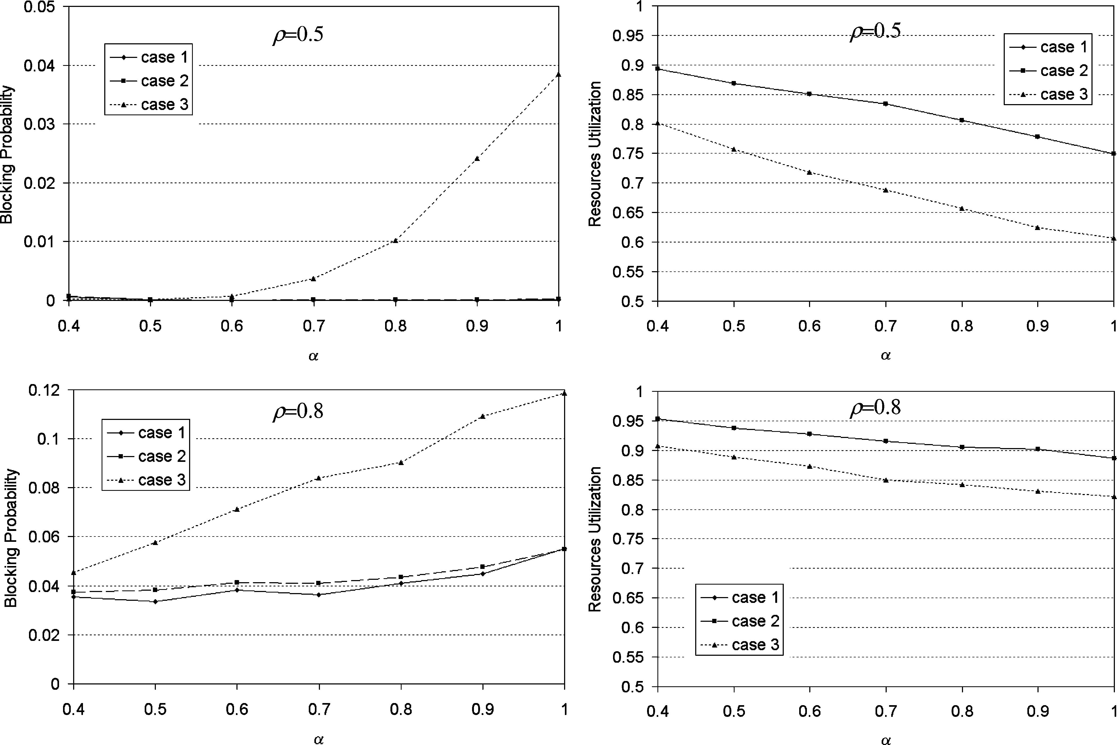



IOVANNA et al.: TRAFFIC ENGINEERING SOLUTION FOR MULTILAYER NETWORKS BASED ON THE GMPLS PARADIGM
1737

Fig. 5. Connection blocking probability and network resources utilization versus , for the three different trafﬁc relationship cases, with = 0:5 (top) and
= 0:8 (bottom) and = 0:5.

have been evaluated for the three aforementioned cases, and for
two different values of . The performances are calculated in
terms of the connection blocking probability and the optical net-
work resources utilization. The connection blocking probability
is deﬁned as the number of rejected connection requests with
respect to the total number of connection requests. The optical
network resources utilization is deﬁned as the average ratio be-
tween the number of the used wavelengths and of the available
wavelengths for each optical link.
By means of a simulative analysis, it has resulted that in order
to make negligible the dependence of the simulation results on
trafﬁc matrix patterns, the simulative curves have been averaged
on 20 different matrices.
Fig. 5 shows the connection blocking probability and the net-
work resources utilization versus the ﬂexibility factor , for the
three case studies, when the TE strategy is applied. Two different

10 and 10 . This means that the dynamic routing is able
to promptly react to trafﬁc changes that could not be predicted
during the provisioning phase. In fact, even though in Case 2 the
trafﬁc distribution varies signiﬁcantly with respect to the one es-
timated by the trafﬁc matrix (differently from Case 1), the TE
system succeed in rearranging the routes’ distribution in order to
track the current trafﬁc demand. In addition, the blocking proba-
bility, in both those cases, is almost independent of ; hence, the
designer would favorably operate with high values of in order
to reduce network resource utilization. This is a further conﬁr-
mation of the effective cooperation between off-line and on-line
procedures. Clearly, the resource utilization curves in both Case
1 and 2 coincide, since the trafﬁc matrices used in the network
conﬁguration phase are the same.
The role of is much more evident in Case 3, where the ac-
tual trafﬁc load becomes 25% bigger with respect to the esti-

network load conditions (
and
) are consid-
mated one. In fact, the blocking probability decreases rapidly as

ered, assuming the HP trafﬁc is a half of the total offered trafﬁc
.
decreases at the expense of resource utilization. This means
that the choice of the value depends on the trade off between

When
(no enhanced ﬂexibility is introduced during
blocking probability and resource utilization. This behavior is

the provisioning phase), the blocking probability has the highest
value, while the network resources utilization shows the lowest
due to the way the routing algorithms operate. In fact, as de-
creases, the provisioning algorithm provides a logical topology

value, for both values of .
that is “more meshed” respect to the case of
, thus facili-

Interestingly, Case 2 and Case 1 show the same behavior in
terms of blocking probability. Speciﬁcally, for values of
tating the task of the dynamic routing. In particular, an value
in the range [0.5–0.7] leads to an improvement of the network

, the distance between the blocking probability curves is of
blocking probability of about 90% for
and 30% for

the order of 10 , while for , it is in the range between
. These results correspond to a reasonable increase of


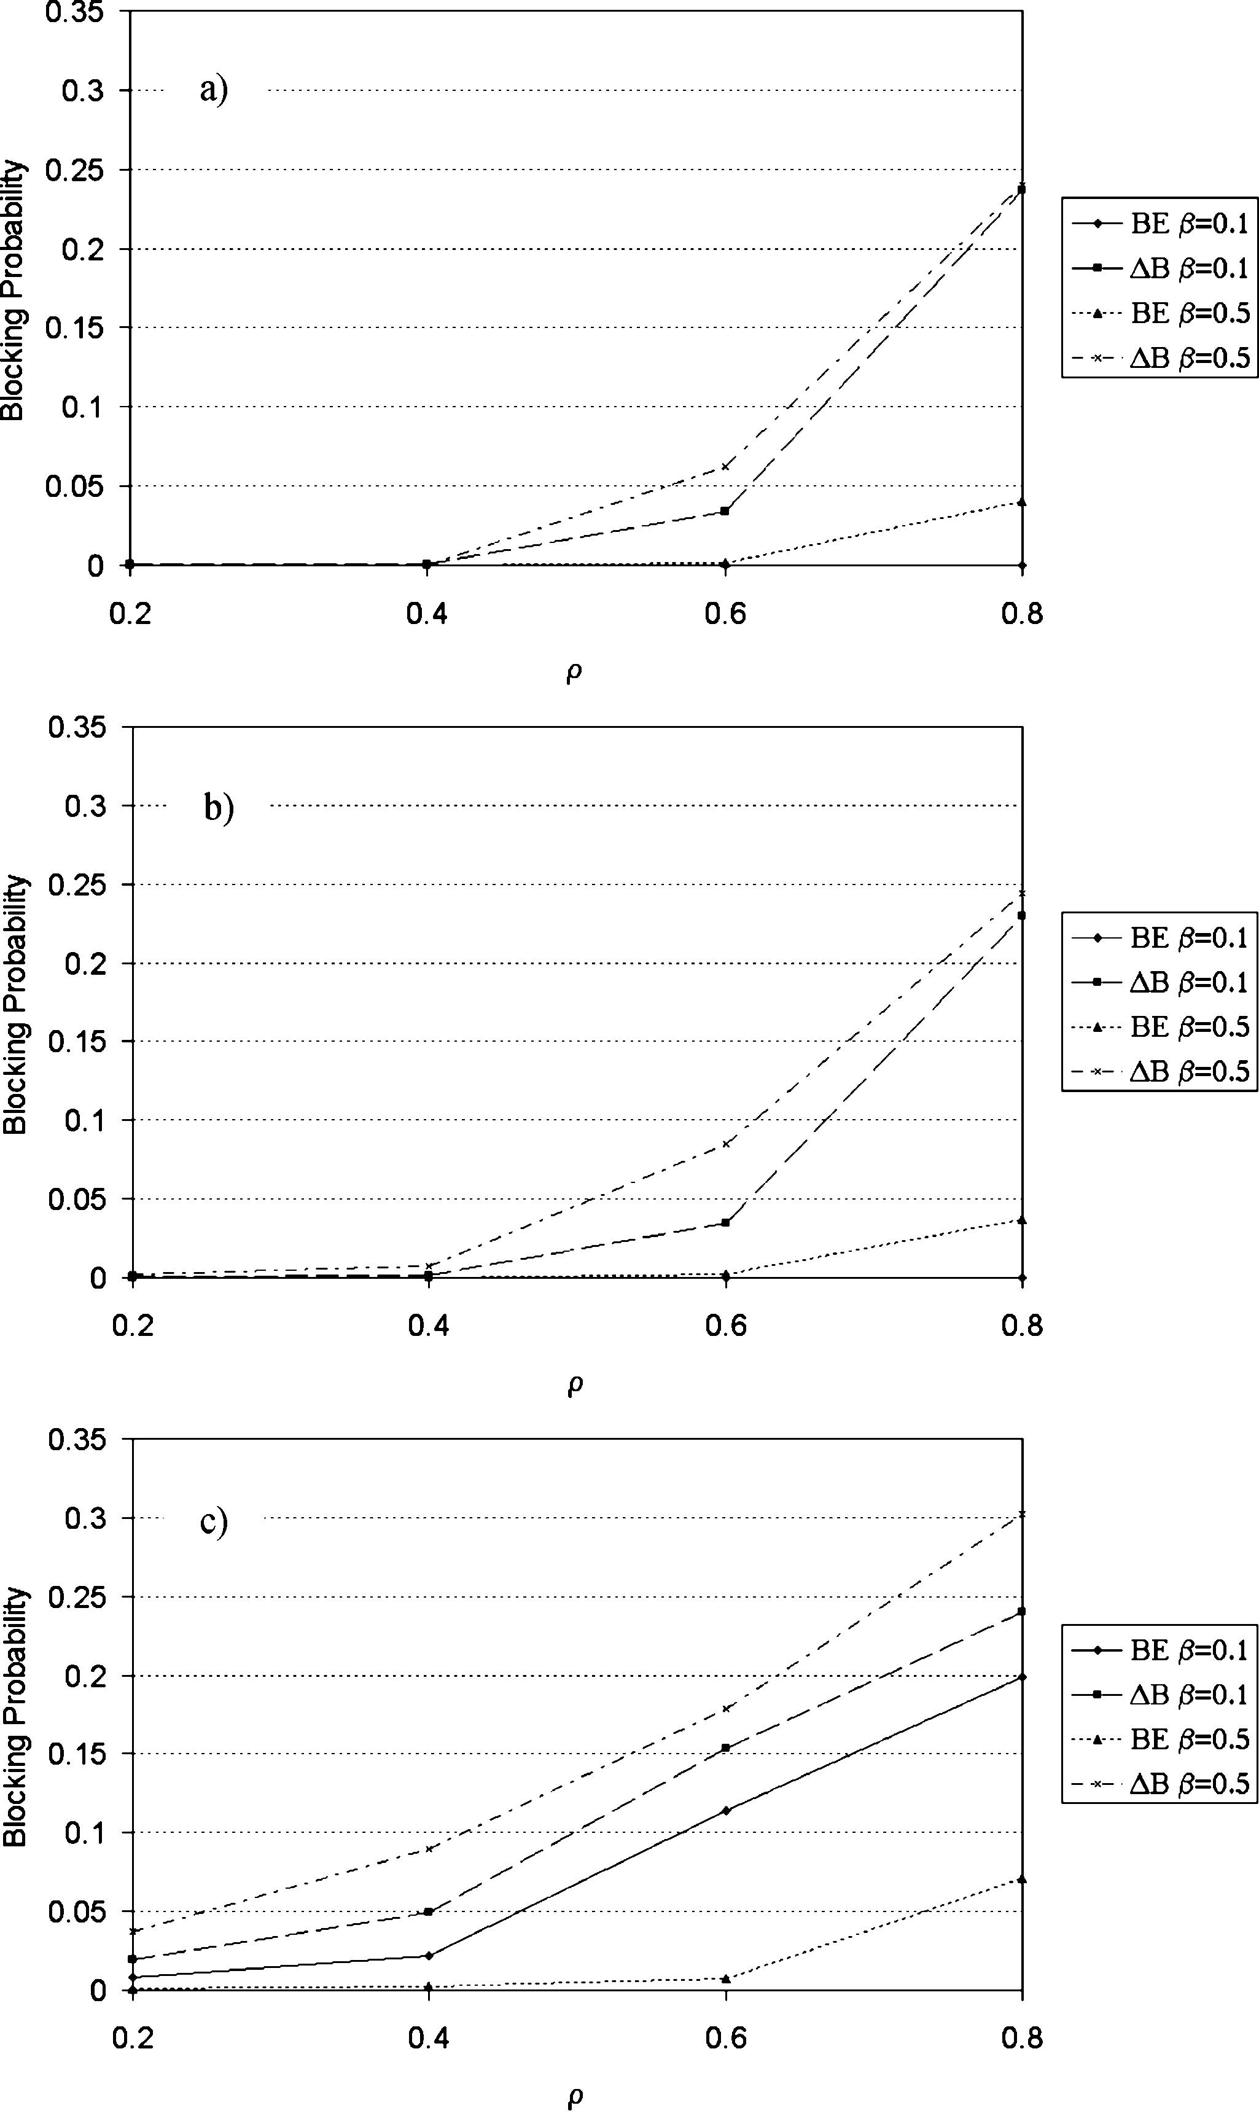
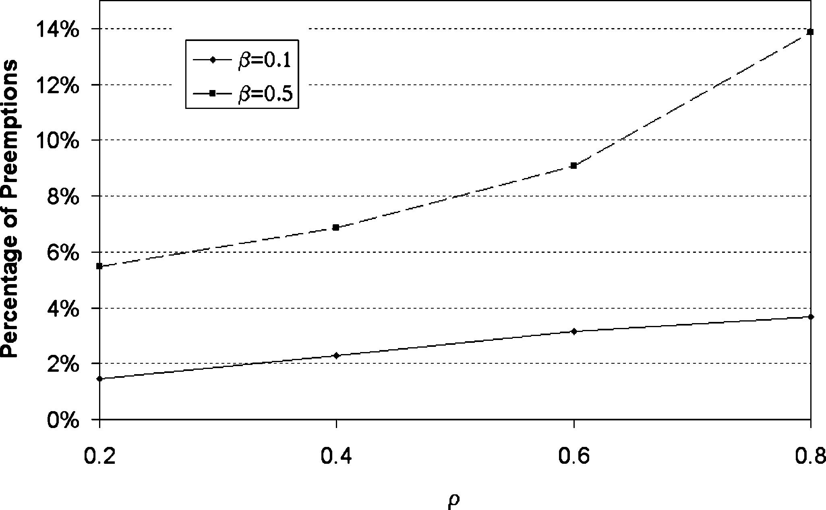
1738

network resources utilization, i.e., 15% for
.
IEEE JOURNAL ON SELECTED AREAS IN COMMUNICATIONS, VOL. 22, NO. 9, NOVEMBER 2004

and 4% for

The performance relating to Case 3 is worth being high-
lighted: even in presence of an appreciably increased trafﬁc
volume (25%) the TE is robust enough to cope with it, at a
reasonable expense in terms of resource utilization. Of course,
an overprovisioning approach would have led to similar per-
formance, but at a much higher price in terms of network
resources.
To better evidence this point, the performance of the TE
system have been compared, in all the considered case studies,
with an alternative approach based on overprovisioning, since,
to the best of our knowledge, there are no integrated solutions
of TE in multilayer networks reported in the literature. The
alternative approach used as a reference, called dedicated
bandwidth (DB), assumes that the bandwidth reserved for the
HP trafﬁc cannot be accessed by any LP trafﬁc request, but it
is completely dedicated to HP; even when the HP LSPs are not
requiring the maximum bandwidth allowed by their SLAs. It
can be regarded as a solution that uses overprovisioning just for
the HP trafﬁc that requires the mission-critical performance.
Of course, any approach making a massive use of overprovi-
sioning would lead to good performance at the expense of a
huge utilization of network resources. Comparing the resource
utilization in these cases with the one relating to TE would not
add anything meaningful.
Fig. 6 shows in fact the blocking probability versus the trafﬁc
load , in the three relevant cases, respectively. Each ﬁgure re-
ports the comparison between the TE approach and DB ap-
proach, for two different values of percentage of HP trafﬁc with

respect to the total amount of trafﬁc (
and
).

All the reported ﬁgures have been evaluated assuming the same

value of the ﬂexibility factor
. This value corresponds

to a reasonable tradeoff between performance and resource uti-
lization, as derived from Fig. 5. In all the considered cases, it
is evident the clear improvement of TE with respect to the DB
approach. This is essentially due to the ﬂexible use of the band-
width resource that is achieved by the BE.
It can be observed from Fig. 6 that the advantage of TE with
respect to the DB approach is more evident when the parameter
is higher. This is because the higher is the percentage of HP
trafﬁc with respect to the total offered trafﬁc, the higher is the
portion of bandwidth temporarily released by HP that can be
utilized by BE to accommodate LP LSPs.
In particular, it is meaningful to evaluate the extra portion
of trafﬁc that the TE is able to accommodate with respect
to the DB approach, for a given blocking probability (e.g.,

Fig. 6. Comparison between the BE and the DB strategies in terms of
connection blocking probability versus for different values of with
= 0:6: (a) case 1; (b) case 2; and (c) case 3.

Blocking Probability
). Speciﬁcally, for
the

gain obtained by TE is more than 50%, considering the cases
1 and 2 [Fig. 6(a) and (b)], and more than 300% in the Case 3
[Fig. 6(c)].
Basically, the advantages of TE with respect to an approach
based on overprovisioning is obtained at the expense of the
number of operations relating to preemption and rerouting that
are needed to implement BE, and the amount of signaling re-
quired to actualize the solution.
In order to evaluate the amount of preemption that the strategy

Fig. 7. Number of preemption operations required in the case = 0:1 and in
the case = 0:5, normalized to the average number of LP LSP requests.

LSPs with respect to the total number of LP LSPs accommo-

accomplishes, Fig. 7 reports the percentage of preempted LP
dated in the network, for
and
, versus the

IOVANNA et al.: TRAFFIC ENGINEERING SOLUTION FOR MULTILAYER NETWORKS BASED ON THE GMPLS PARADIGM

trafﬁc load. For the sake of brevity, that ﬁgure has been only re- ACKNOWLEDGMENT
ported in the worst case, that is Case 3 where BE is more often
1739

invoked. The obtained low values indicate that the complexity
of dynamic operations, required to achieve BE, is limited and
does not prevent practical implementation.
The complexity of the TE system has been experienced
during the realization of a test bed [28], which emulates the
control plane of an IP/MPLS network, implemented in a
distributed approach, supporting real routing and signaling
protocols (OSPF-TE and RSVP-TE), in agreement with IETF
standards. In practice, all the considered modules and related
algorithms have been implemented in each node of the test
bed network. The experiments made on the test bed show the
feasibility of the key functions and of the TE system as a whole,
in terms of scalability, stability, and QoS performance [28].

V. CONCLUSION
This paper reports an integrated TE system, which applies
to a multilayer network, in a GMPLS-based multiservice sce-
nario. A performance analysis assessing the feasibility of the
proposed solution is also reported. In particular, the described
TE system is based on two key novel components: 1) a hy-
brid routing scheme and 2) a system able to handle priority,
preemption, and rerouting, called bandwidth engineering. The
former allows an optimization of the use of the network re-
sources and, at the same time, an improvement of the dynamic
performance of the network and the robustness against trafﬁc
unpredictability. The latter further improves the performance of
the network by achieving an elastic use of the bandwidth, so that
the temporarily unused bandwidth by HP trafﬁc is not wasted,
but put at disposal of LP trafﬁc. As a result, the proposed TE
guarantees QoS requirements to be fulﬁlled, while at the same
time it optimizes the use of the network resources, increases the
ﬂexibility of the network, and allows a large amount of trafﬁc to
be accommodated.
In order to assess the effectiveness of the considered TE
system, the performances have been evaluated for three relevant
case studies, according to the relationships between the trafﬁc
characteristics predicted off-line and the ones resulting from
the current requests. Namely, a) Case 1: the current trafﬁc
distribution and volume do not appreciably differ from the ones
predicted by the trafﬁc matrix; b) Case 2: the trafﬁc volumes
are the same, but the current trafﬁc distribution appreciably
differs from the predicted one; and c) Case 3: the current trafﬁc
volume and distribution appreciably differ from the predicted
ones.
The simulation results show the robustness of the proposed
solution. In fact, the system is able to react to trafﬁc changes by
rearranging network resources, even when trafﬁc volume and re-
lated distribution vary appreciably with respect to the predicted
ones.
The advantage of TE with respect to an applicable overprovi-
sioning approach (DB: dedicated bandwidth) has been shown in
all the individuated case studies. Actually, for a given blocking
probability, the gain obtained by TE with respect to DB in terms
of accommodated trafﬁc is quite evident.
In addition, it has been shown that since the number of pre-
emption and rerouting operations is quite limited in practice, it is
reasonable to assume that the complexity of TE is manageable.
This paper considers a TE strategy that has been partially de-
veloped in the framework of the Ericsson project Advance So-
lutions of Trafﬁc Engineering: Research, Implementations and
eXtensions (ASTERIX), and in part carried out within the Na-
tional project TANGO, in the framework of the FIRB program.
The authors wish to thank all the participants of the project.
In particular, they are grateful to A. Bosco and E. Manconi for
the development of the bandwidth-engineering concept and for
fruitful discussions.

REFERENCES
[1] M. Listanti, V. Eramo, and R. Sabella, “Architectural and technological
issues for future optical Internet networks,” IEEE Commun. Mag., vol.
38, pp. 82–92, Sept. 2000.
[2] X. Xiao and L. Ni, “Internet QoS: a big picture,” IEEE Network, pp.
8–33, Mar./Apr. 1999.
[3] D. Awduche et al., “Overview and principles of Internet trafﬁc engi-
neering,” IETF, RFC 3272, May 2002.
[4] E. Mannie et al., “Generalized multi-protocol label switching (GMPLS)
architecture,” work in progress IETF draft <draft-ietf-ccamp-gmpls-ar-
chitecture-02.txt>.
[5] E. Rosen, A. Viswanathan, and R. Callon, “Multiprotocol label
switching architecture,” IETF, RFC 3031, Jan. 2001.
[6] D. Awduche et al., “Requirements for trafﬁc engineering over MPLS,”
IETF RFC 2702, Sept. 1999.
[7] X. Xiao, A. Hannan, B. Bailey, and L. M. Ni, “Trafﬁc engineering with
MPLS in the Internet,” IEEE Network, pp. 28–33, Mar./Apr. 2000.
[8] A. Banerjee et al., “Generalized multiprotocol label switching: An
overview of routing and management enhancements,” IEEE Commun.
Mag., pp. 144–150, Jan. 2001.
[9] , “Generalized multiprotocol label switching: an overview of sig-
naling enhancements and recovery techniques,” IEEE Commun. Mag.,
pp. 144–151, July 2001.
[10] B. Wen and K. M. Sivalingam, “Routing, wavelength and time-slot as-
signment in time division multiplexed wavelength-routed optical WDM
networks,” in Proc. IEEE INFOCOM, New York, June 2002.
[11] T. Fabry-Asztalos, N. M. Bhide, and K. M. Sivalingam, “Adaptive
weight functions for shortest path routing algorithms for multi-wave-
length optical WDM networks,” in Proc. IEEE Int. Conf. Communica-
tions, New Orleans, LA, June 2000.
[12] D. Banerjee and B. Mukherjee, “Wavelength-routed optical networks:
linear formulation, resource budgeting tradeoffs, and a reconﬁguration
study,” in Proc. Conf. Computer Communications (IEEE Infocom),
Kobe, Japan, Apr. 1997, p. 269.
[13] T. Cinkler, D. Marx, C. P. Larsen, and D. Fogaras, “Heuristic algo-
rithms for joint conﬁguration of the optical and electrical layer in
multi-hop wavelength routing networks,” in Proc. INFOCOM 2000, pp.
1000–1009.
[14] P. Iovanna, M. Settembre, and R. Sabella, “A trafﬁc engineering system
for multi-layer networks based on the GMPLS paradigm,” IEEE Net-
work, Mar. 2003.
[15] R. Sabella, M. Settembre, G. Oriolo, F. Razza, F. Ferlito, and G.
Conte, “A multilayer solution for path provisioning in new-generation
optical/MPLS networks,” IEEE J. Lightwave Technol., vol. 21, pp.
1141–1155, May 2003.
[16] R. Sabella, P. Iovanna, G. Oriolo, and P. D’Aprile, “Strategy for dy-
namic routing and grooming of data ﬂows into lightpaths in new genera-
tion network based on the GMPLS paradigm,” Kluwer Photon. Network
Commun., vol. 7, pp. 131–144, Mar. 2004.
[17] A. Bosco, E. Manconi, R. Sabella, and L. Valentini, “An innovative so-
lution for dynamic bandwidth engineering in IP/MPLS networks with
QoS support,” Kluwer Photon. Network Commun., vol. 7, pp. 37–42,
Jan. 2004.
[18] B. Davie and Y. Rekhter, MPLS Technology and Applications. New
York: Academic, 2000.
[19] R. Coltun, “The OSPF opaque LSA option,” RFC 2370, July 1998.
[20] D. Katz, “Trafﬁc engineering (TE) extensions to OSPF version 2,” IETF
RFC 3630, Sept. 2003.
[21] D. Awduche et al., “RSVP-TE: Extensions to RSVP for LSP tunnels,”
RFC 3209, Dec. 2001.
[22] M. Peyravian and A. D. Kshemkalyani, “Connection preemption: issues,
algorithms, and a simulation study,” in Proc. IEEE INFOCOM, vol. 1,
1997, pp. 143–151.






1740
IEEE JOURNAL ON SELECTED AREAS IN COMMUNICATIONS, VOL. 22, NO. 9, NOVEMBER 2004

[23] E. Mannie et al., “Generalized multi-protocol label switching (GMPLS)
architecture,” work in progress IETF draft <draft-ietf-ccamp-gmpls-ar-
chitecture-07.txt>, Nov. 2003.
[24] L. Berger et al., “Generalized multi-protocol label switching (GMPLS)
signaling functional description,” IETF RFC 3471, Jan. 2003.
[25] J. P. Lang, “Link management protocol,” work in progress IETF draft
<draft-ietf-ccamp-lmp-10.txt>, Oct. 2003.
[26] K. Kompella et al., “LSP hierarchy with generalized MPLS TE,” work in
progress IETF draft <draft-ietf-mpls-lsp-hierarchy-08.txt>, Mar. 2002.
[27] G. Conte, P. Iovanna, M. Settembre, R. Sabella, and L. Valentini, “A
trafﬁc engineering solution for GMPLS network: a hybrid approach
based on off-line and on-line routing methods,” in Proc. ONDM Conf.,
vol. 1, Budapest, Hungary, Feb. 4–6, 2003, pp. 313–331.
[28] A. Bosco, A. Botta, M. Intermite, P. Iovanna, and S. Salsano, “Dis-
tributed implementation of a pre-emption and re-routing mechanisms
for a network control based on IP/MPLS paradigm,” in Proc. ONDM
Conf., vol. 2, Budapest, Hungary, Feb. 4–6, 2003, pp. 821–839.

Paola Iovanna (M’03) was born in Rome, Italy, in
1971. She received the degree in electronics engi-
neering from the University of Rome “Tor Vergata”
in 1996.
From 1995 to 1997, she had collaboration as fel-
lowship with a research center “U. Bordoni,” Rome,
where she dealt with advanced ﬁber-optic communi-
cations and optical networking issues. From 1997 to
2000, she was with “Telecom Italia,” where she was
involved in experimentation of new services based
on different access technologies (as XDSL, Frame
Relay, etc.). In 2000, she joined Ericsson Lab Italy, Rome, in the Research De-
partment where she dealt with networking issues using MPLS and GMPLS tech-
nique. She is involved in the activity carried on in the framework of the Network
of Excellence Euro-NGI, where she is responsible for the activity “Trafﬁc En-
gineering for Next Generation Network.” She holds two patents on dynamic
routing solutions and trafﬁc engineering system for multilayer networks based
on the GMPLS paradigm for networks based on the GMPLS model, and she is
author of several papers on trafﬁc engineering in GMPLS-based networks.

Marina Settembre (M’03) was born in Rome, Italy,
on July 6, 1960. She received the Laurea degree in
physics from the University of Rome “La Sapienza”
in 1985.
In the same year, she was granted a fellowship
at the Fondazione Ugo Bordoni, working on in-
novative materials for optical devices. From 1986
to September 2000, she was a Research Scientist
at the Fondazione Ugo Bordoni in the Optical
Communication Division, focusing ﬁrst on optical
devices for signal routing/processing and then on
physical layer modeling and on high-capacity optical transmission systems. In
October 2000, she joined Ericsson Lab Italy, Rome, where she works in the
Research Department on network architectures, trafﬁc engineering strategies,
and related algorithms and control plane deﬁnition for new generation networks
based on the GMPLS paradigm. Her present research interests are also in the
area of broadband wireless access technologies and architectures, focusing
on trafﬁc management, media access control protocols, and quality of service
for packet-based communication in wireless systems. She has been actively
involved in several European COST, ACTS, and IST projects (Cost 239, Cost
245, Cost 266, ACTS-Upgrade, ACTS- Esther, IST Atlas, IST Embrace) and
is at the moment participating in the IST Integrated Project Broadwan in the
Sixth Framework Programme. She has published more than 90 papers on
international scientiﬁc journals and conferences and is author of the book
Non-Linear Optical Communication Networks (New York: Wiley, 1998).

Roberto Sabella (M’92–SM’02) was born in Rome,
Italy, on December 10, 1962. He received the Laurea
degree in electronic engineering from the University
of Rome “La Sapienza,” Rome, Italy, in 1987.
He then joined Ericsson, Rome, where he was
involved ﬁrst in hardware design and subsequently in
research activities on advanced ﬁber optic communi-
cation systems. His research interests have covered
the ﬁelds of optical device technology, high-speed
optical communication systems, WDM optical
networks, and next generation Internet networks. In
May 1997, he became the technical coordinator of the research consortium
CoRiTeL. Since 1999, he has been the manager of the Research and Innovation
Unit in Ericsson Lab Italy. He holds ﬁve patents relating to optical networks
and trafﬁc engineering strategies, is coauthor of a book on high-speed optical
communications, and author or coauthor of about 100 papers published in either
international scientiﬁc/technical journals or international conferences. He has
been Lecturer (professore a contratto) at the University of Rome “Tor Vergata,”
and at the Polytechnic of Bari, both in Italy. Currently, he is Adjunct Professor
of Design of Telecommunications Equipment at the University of Rome “La
Sapienza.” He is a member of the editorial board of the journal Photonic
Network Communications (Kluwer). For the same journal, he has operated
twice as Guest Editor for a special issue on WDM transport networks and on
routing and failure restoration strategies in optical networks. He was also Guest
Editor of a special issue on optical networks for the journal Computer Network
(Elsevier). He will be the Chairman of the conference Next Generation Internet
Networks, supported by the IEEE Communication Society, organized on behalf
of the European Network of Excellence EURO-NGI.
Prof. Sabella has been Guest Editor of the IEEE COMMUNICATION MAGAZINE
(Special Issue on “Optical Networking Solutions for Next Generation Internet
Networks”) and the IEEE NETWORK (Special Issue on “Trafﬁc Engineering in
Optical Networks).

Giulia Conte was born in Rome, Italy, in December
26, 1976. She received the degree in telecommuni-
cations engineering from “Tor Vergata” University,
Rome, in 2001. Her thesis was about routing and
failure restoration strategies in the presence of
different trafﬁc classes in WDM networks.
In February 2001 she joined CoRiTeL, Rome,
where she takes part in the research activity of the
“Optical Networks” group. Her present research
interests include trafﬁc engineering strategies and re-
lated algorithms, network architectures, and control
plane deﬁnition for new generation networks based on the GMPLS paradigm.

Lucia Valentini was born in Perugia, Italy, on
January 19, 1976. She received the degree in elec-
tronical engineering from the University of Perugia
in November 2002. Her thesis was about trafﬁc
engineering strategies in presence of different trafﬁc
classes in GMPLS networks.
In December 2002 she joined CoRiTeL, Rome,
Italy, where she involved in development of coding
and transcoding functions for MPEG4 application
transport.

